ACTIVITY BASED LEARNING

Name: Anne Keerthana
Roll num: 26000006
Branch: CSE
Section: 01
Year:2026-30

CASE STUDY-01: PESONAL PORTFOLIO WEBSITE
Create a personal website displaying a profile, educational qualifications, technical skills, hobbies, projects, achievements, resume, and contact information. Use CSS animations, responsive layouts, and interactive navigation effects.

Explanation:
I created a Personal Portfolio Website to display my personal information, educational qualifications, skills, hobbies, and projects. HTML was used to organize the content, and CSS was used to style the webpage.

HTML Tags Used
- <h1>, <h2> – Used to display main headings and subheadings.
- <p> – Used to display paragraphs.
- <div> – Used to group related content.
- <section> – Used to divide the webpage into different sections.
- <table>, <tr>, <th>, <td> – Used to display educational details in a table.
- <ul>, <li> – Used to display lists of skills and hobbies.
- <a> – Used to create links.
- <link> – Used to connect the favicon file to the HTML webpage.
- Favicon: I added a favicon to the webpage using the <link> tag. It is a small icon displayed in the browser tab that helps identify the website.
CSS Properties Used
- background-color – Sets the background colour.
- color – Changes the text colour.
- font-family – Sets the font style.
- text-align – Aligns the text.
- padding – Adds space inside an element.
- margin – Adds space outside an element.

Screenshots:
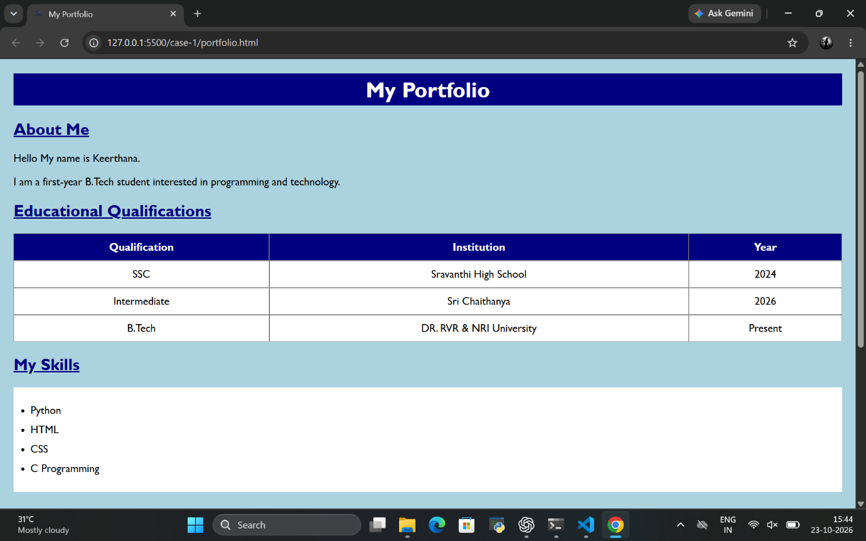

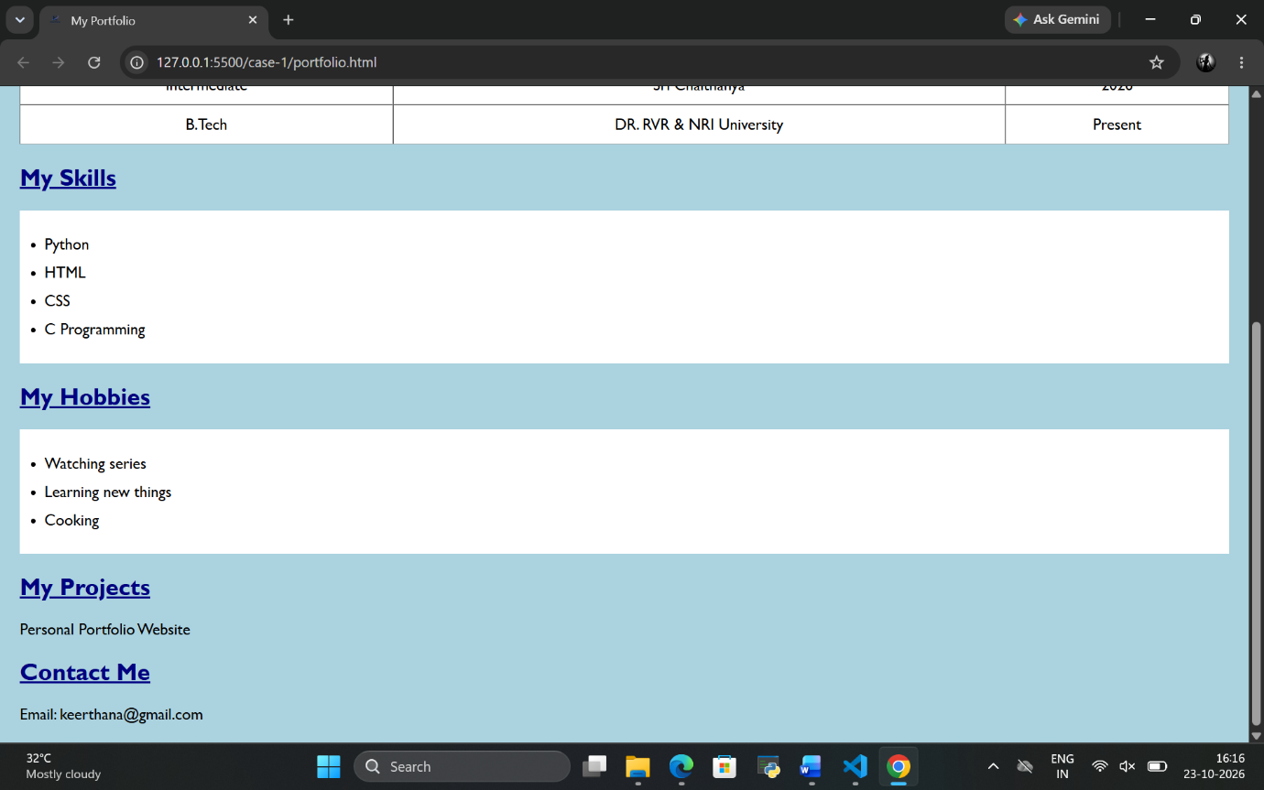

Case study-02 : COLLEGE INFORMATION AND ADMISSION WEBSITE
Design a college website displaying institutional information, departments, courses, faculty profiles, admissions procedures, campus facilities, events, and contact details. Create a navigation bar, banner, and responsive information cards.

Explanation:
I developed a College Website to display college information, courses, facilities, admission details, and contact information. HTML was used to structure the content, and CSS was used to improve the webpage's appearance.
HTML Tags Used
- <h1>, <h2> – Used to display headings.
- <p> – Used to display college information.
- <div> – Used to group related content.
- <section> – Used to organize different parts of the webpage.
- <nav> – Used to create the navigation section.
- <a> – Used to create navigation links.
- <ul>, <li> – Used to display courses and facilities.
- <button> – Used to create the Apply Now button.
- <footer> – Used to display footer information.
- <link> – Used to connect the favicon file to the HTML webpage.
- Favicon: I added a favicon to the webpage using the <link> tag. It is a small icon displayed in the browser tab that helps identify the website.
CSS Properties Used
- background-color – Sets background colours.
- color – Changes text colours.
- text-align – Aligns the text.
- font-size – Sets the text size.
- padding – Adds space inside elements.
- margin – Adds space outside elements.
- text-decoration – Adds or removes text decoration.
- border-radius – Rounds the corners of elements.

Screenshots:

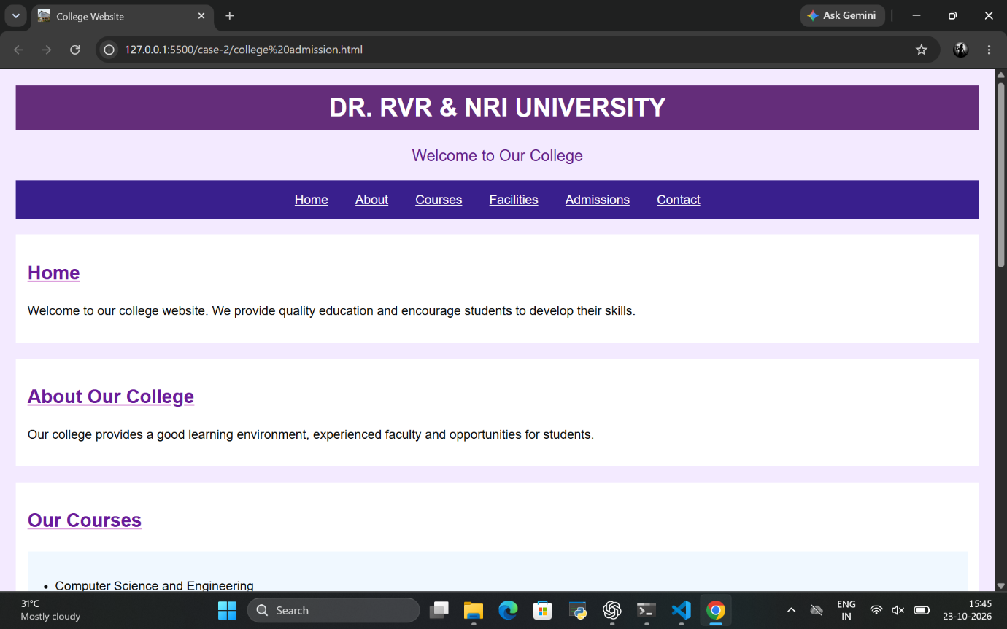

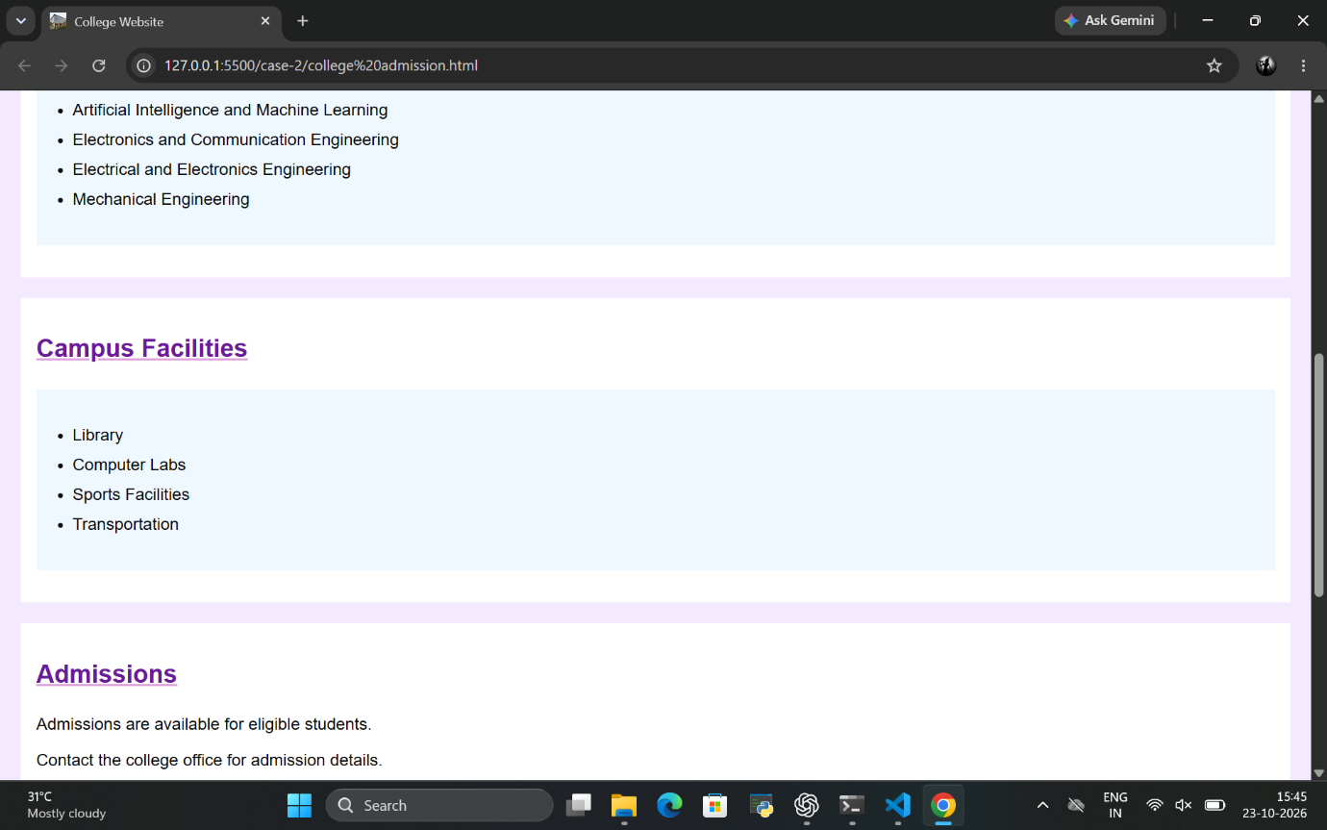

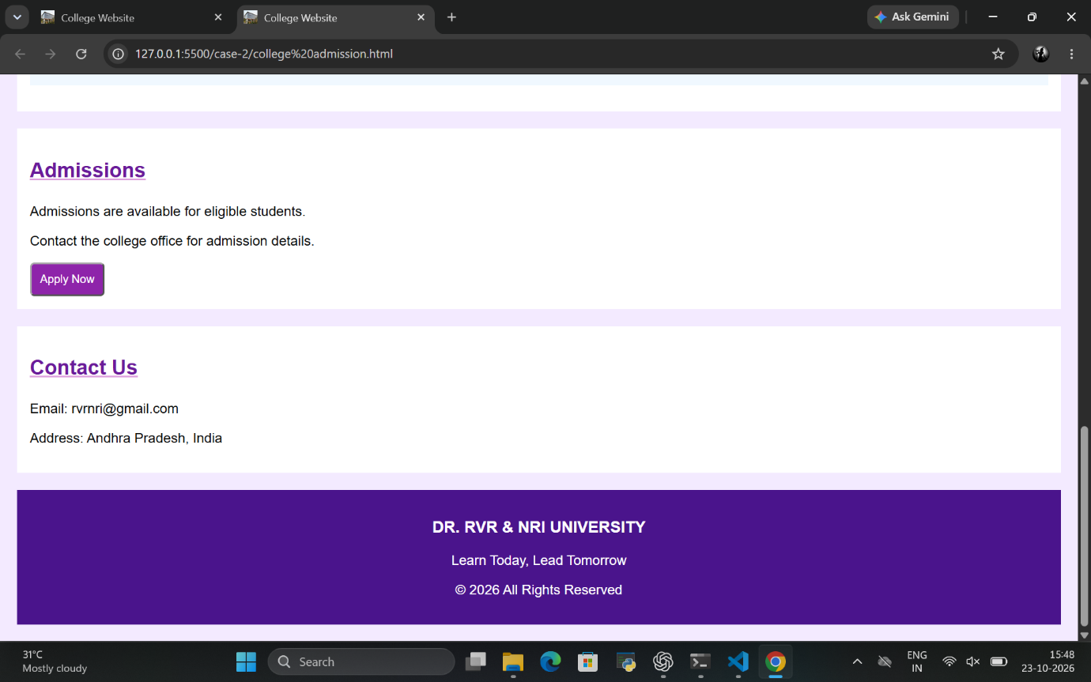

CASE STUDY-16 : TRAVEL AGENCY WEBSITE
Develop a travel portal presenting holiday packages, popular destinations, trip durations, prices, itineraries, and travel inquiry forms. Use destination cards, hero images, and responsive layouts.

Explanation:
I created a Travel Agency Website to display popular tourist destinations, travel packages, prices, and a travel inquiry form. I used HTML to organize the content and CSS to style the webpage and display destination images.
HTML Tags Used
- <h1>, <h2>, <h3> – Used to display headings.
- <p> – Used to describe tourist destinations.
- <div> – Used to group destination details.
- <section> – Used to organize webpage content.
- <nav> – Used to create the navigation bar.
- <a> – Used to create navigation links.
- <img> – Used to display destination images.
- <table>, <tr>, <th>, <td> – Used to display travel package details.
- <form> – Used to group inquiry form elements.
- <label> – Used to describe form fields.
- <input> – Used to accept user information.
- <select>, <option> – Used to provide destination choices.
- <button> – Used to create the Submit Inquiry button.
- <footer> – Used to display footer information.
- <link> – Used to connect the favicon file to the HTML webpage.
- Favicon: I added a favicon to the webpage using the <link> tag. It is a small icon displayed in the browser tab that helps identify the website.
CSS Properties Used
- background-color – Sets the background colour.
- color – Changes the text colour.
- text-align – Aligns the text.
- padding and margin – Add spacing to elements.
- border-radius – Rounds the corners of elements.
- width and height – Set image dimensions.
Screenshots:

